CS4650

Assignment 6: Review of Image Processing Operations

Alexander Kochman

November 15, 2024

**Abstract**

This report discusses some fundamental techniques of image processing; among them are geometric transformations and gradient computations. These methods form the basis of basic image manipulation through translation, scaling, and rotation operators, supplemented with edge detection using gradient operators for feature extraction and object recognition.

**Introduction**

Geometric transformations and gradient computation are an important part of computer vision, whereby systems interpret and manipulate visual data. Geometric transformations, such as translation, scaling, flipping, and rotation, precisely control the adjustments in an image's spatial structure, which are necessary for various applications related to image alignment and/or image augmentation. Gradients provide information about the change in intensity, making them very useful in edge detection and contour analysis. Gradients, along the horizontal and vertical directions, their magnitudes, and orientations collectively provide major information about the texture and structure of an image. In this report, the very basic approach regarding geometric transformations and gradient-based methods is demonstrated with practical examples.

**Results**

Geometric Image Transformations

Original Image

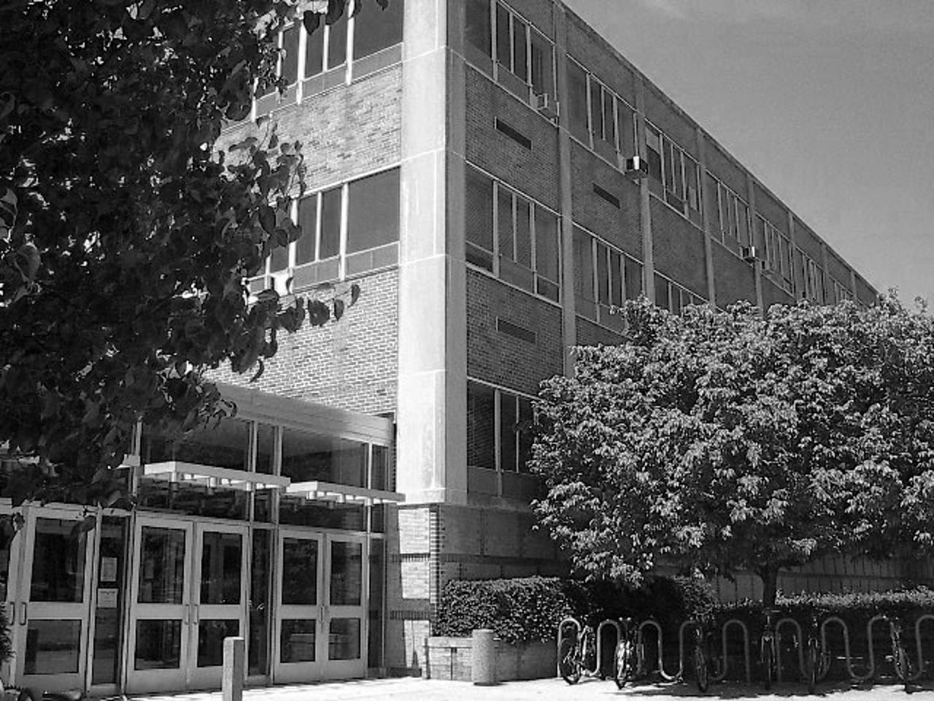

Translated (tx = 300, ty = 200)

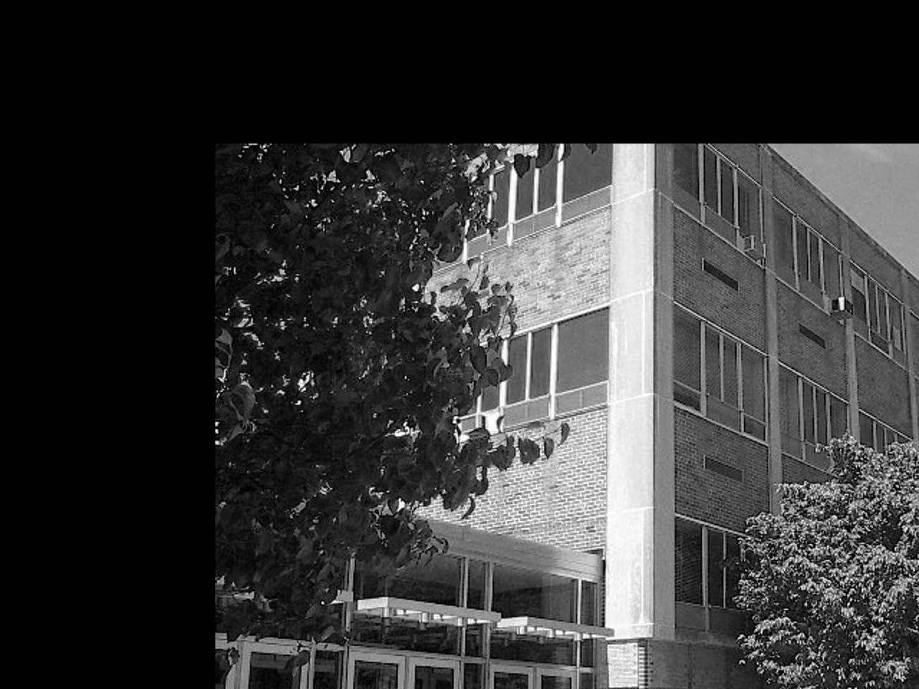

Cropped (x1=500, y1=1,x2=1000, y2=800, s=0.5)

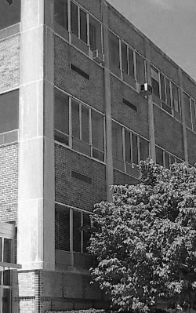

Flipped over y-axis

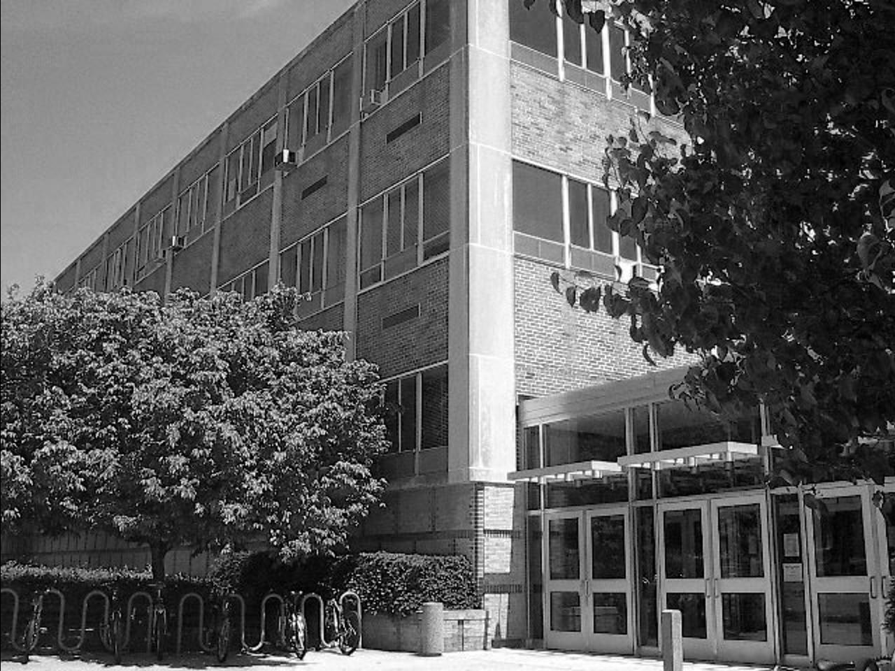

Flipped over x-axis

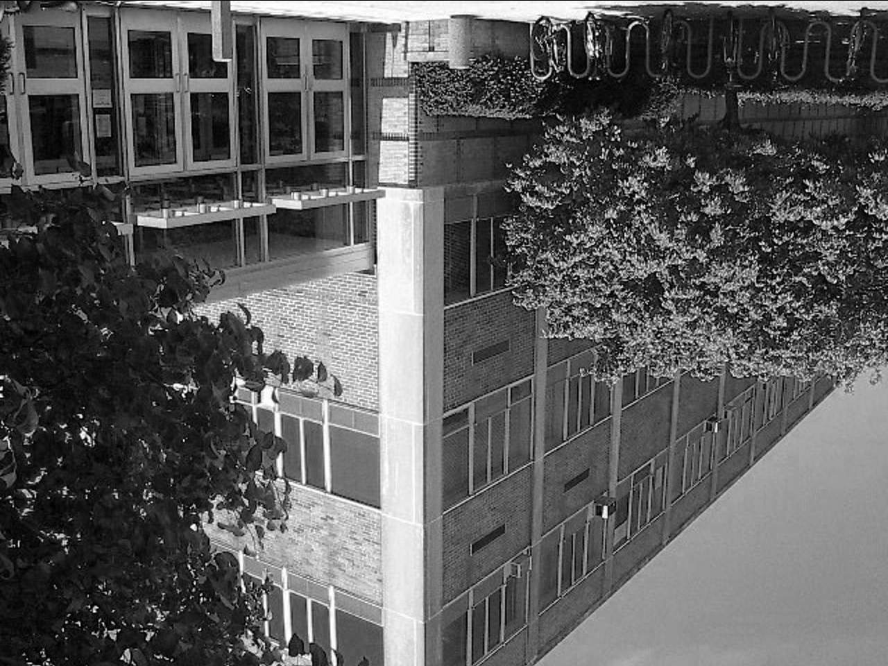

Rotated (60 degrees)

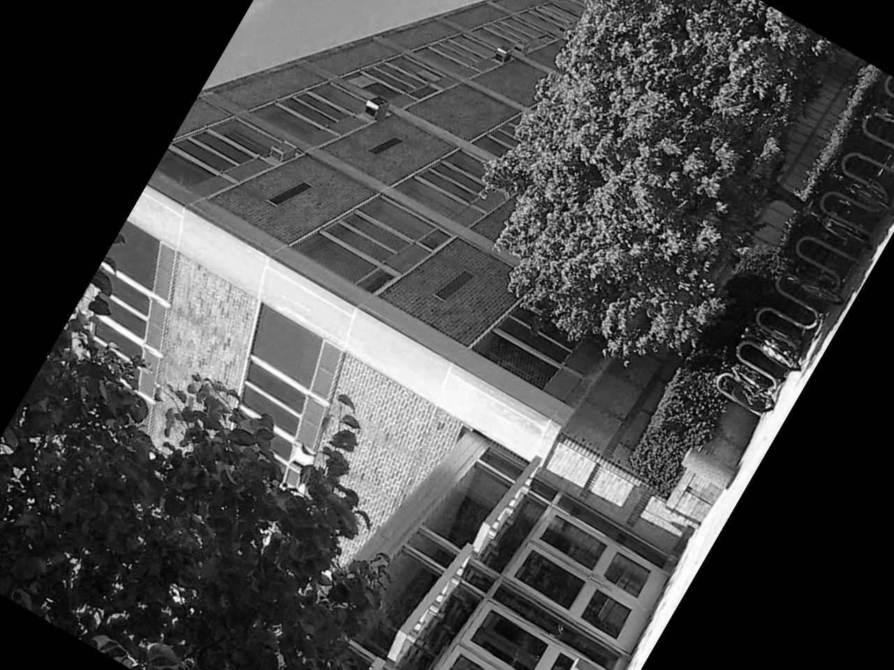

Filled (x1=500, y1=1, x2=1000, y2=800, val=150)

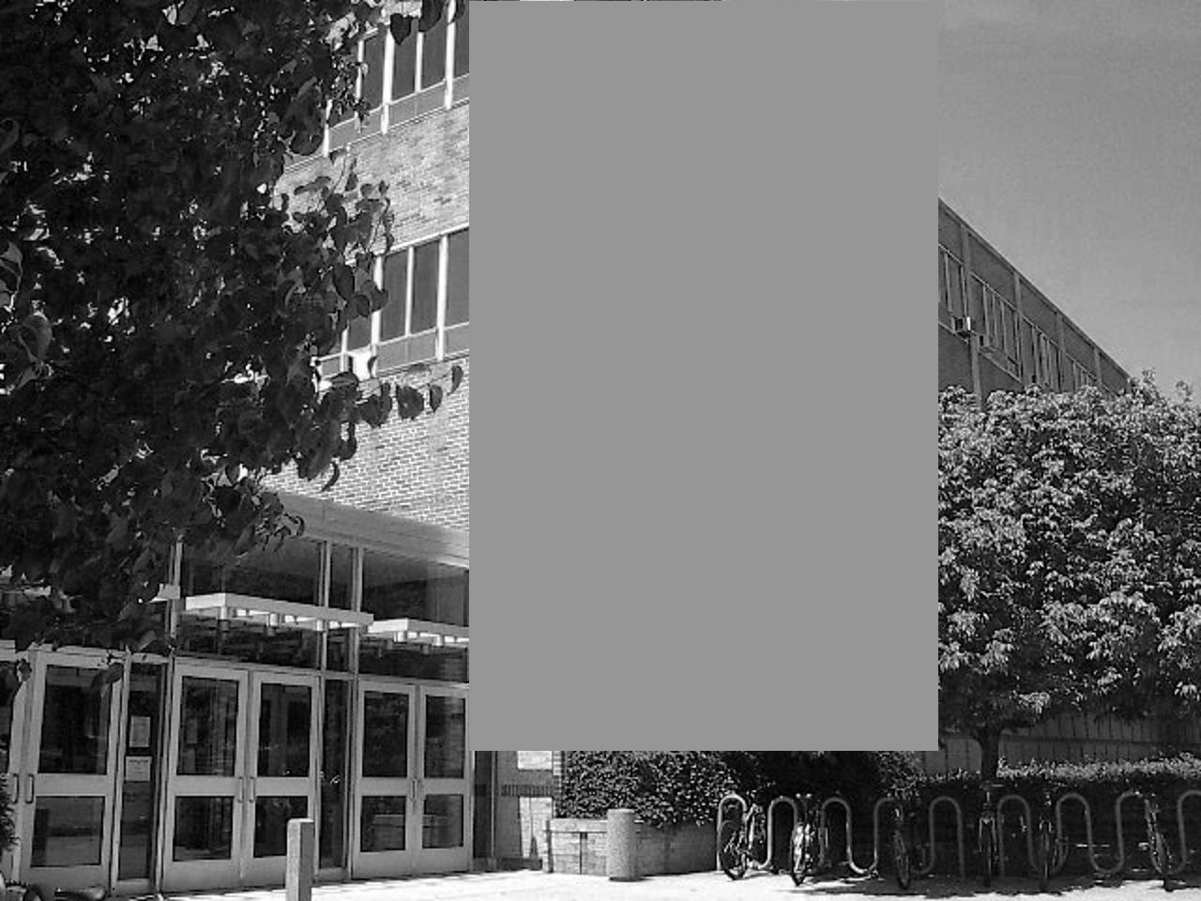

**Edge Detection and Histogram of Gradient Orientations**

(Scale = 5x5)

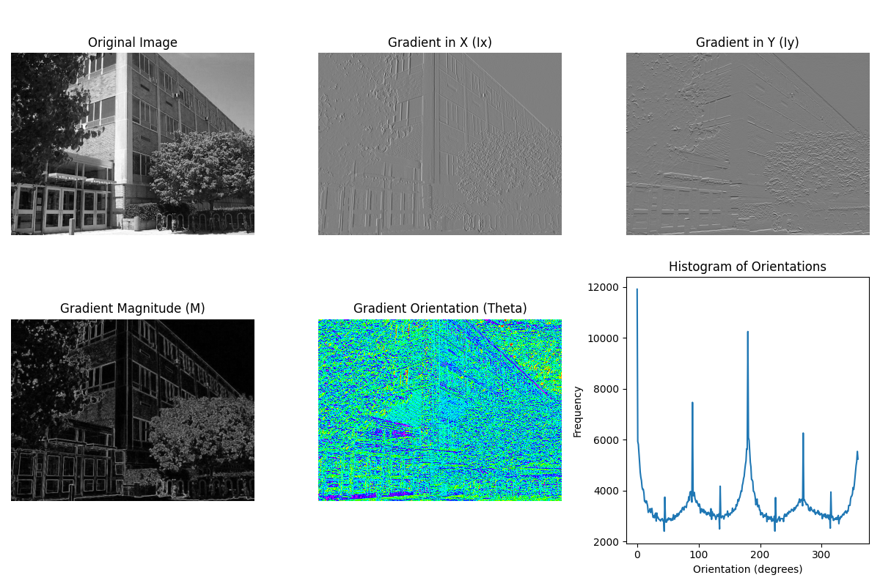

(Scale = 11x11)

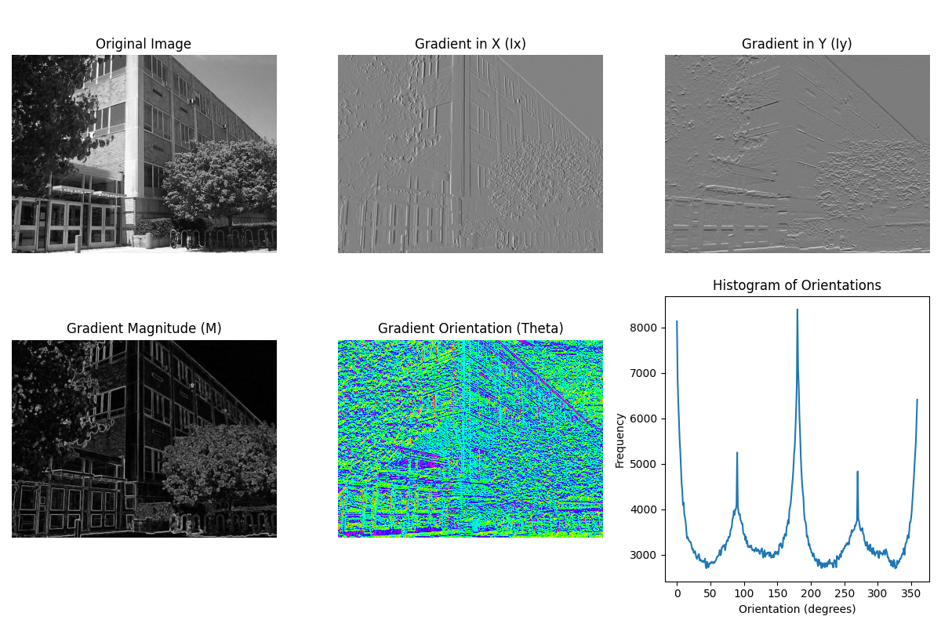

**Conclusion**

These results emphasize the importance of both gradient-based methods and geometric transformations in image processing. Gradient calculations-which include gradients along the X and Y axes, Ix and Iy, magnitude of the gradient M, and gradient orientation Theta-effectively bring out critical features in an image. These methods outline edges, intensity changes, and structural information, important in operations such as edge detection and texture analysis. The orientation histogram gives, in quantitative terms, an overview of the dominant edge directions, further helping to infer the structural composition of the image.

Complementing the gradient analysis, geometric transformations like translation, scaling, and rotation offer strong means of image manipulation with respect to their spatial structure. These enable image alignment, augmentation, and preparation for analysis in such a way that images can be standardized or adjusted to meet the requirements of specific tasks. With this combination of geometric transformations and gradient-based methods, we will be able to develop robust image preprocessing pipelines for object recognition, feature extraction, and contour analysis.